BIRLA INSTITUTE OF TECHNOLOGY & SCIENCE, PILANI
Work Integrated Learning Programmes Division
First Semester 2025-2026
Mid-Semester Test
(EC-2 Regular)
Course No. : AIMLCZC418
Course Title : Introduction to Statistical Methods
No. of Pages = 4

No. of Questions = 6
Nature of Exam : Closed Book
Weightage : 30%
Duration : 2 Hours
Date of Exam : 20-12-2025_FN
Note to Students:
- Please follow all the Instructions to Candidates given on the cover page of the answer book.
- All parts of a question should be answered consecutively. Each answer should start from a fresh page.
- Assumptions made if any, should be stated clearly at the beginning of your answer.
Answer all the questions:
- The data below represent the total fat (in grams per serving) for a random sample of 10 chicken sandwiches from various fast-food chains:
7, 4, 20, 23, 25, 19, 30, 30, 40, 56
- Compute the mean, median, sample standard deviation and interquartile range (IQR). Using the 1.5 × IQR criterion, identify any potential outliers. [3 marks]

- Synthesize your findings from the above to draw statistically sound conclusions
regarding the central tendency, dispersion, and variability of total fat content in chicken sandwiches. Comment on the implications for nutritional consistency and quality control in fast-food offerings. [2 marks]

- A school wants to build a simple system to classify student messages as "Urgent" or "Not Urgent" using the Naïve Bayes classifier. Here is a small sample dataset: [5 marks]
Message ID | Words in Message | Label
1 | assignment due tomorrow please help | Urgent
2 | lunch plans today? | Not Urgent
3 | exam rescheduled urgent attention | Urgent
4 | thanks for the notes | Not Urgent
New Message to Classify: "assignment urgent" Using Naïve Bayes with Laplace smoothing (α = 1), classify this message as Urgent or Not Urgent. Show brief working.

- a) A random variable X has the following probability function:
x | 0 | 1 | 3 | 4 | 5 | 6 | 7
p (x) | 0 | k | 2k | 2k | 3k | k² | 7k² + k

- Find the value of k [1 mark]
- Evaluate P (X < 6), P (X ≥ 6) [1 mark]
- P (0 < X < 5) [1 mark]
b) A factory produces high-precision surgical blades, and quality control data shows that 0.2% (i.e., one-fifth of a percent) of blades are defective. The blades are packed in sterilized packets of 10 each. In a consignment of 10,000 packets, use the Poisson approximation to estimate how many packets contain: (Assume defects occur independently.) [2 marks]

i. No defective blade
ii. Exactly one defective blade
- Let X and Y be continuous random variables with joint probability density function:
f(x,y) = 6x² y if 0 ≤ x ≤ 1, 0 ≤ y ≤ 1 [5marks]
0 otherwise
- Verify that f(x,y) is a valid joint PDF.
- Find the marginal densities f_{X}(x) and f_{Y}(y)
- Compute P(X<0.5, Y>0.5)
- Are X and Y independent? Justify.
- Compute E[X], E[Y] and E[XY].

- The inside diameters of washers produced by an automated manufacturing machine are normally distributed. A random sample of 200 washers yields a mean diameter of 0.500 cm and a standard deviation of 0.005 cm. For proper function in an automotive assembly, each washer must have an inside diameter between 0.492 cm and 0.506 cm. Washers outside this range are classified as defective. Assuming the sample estimates accurately reflect the population parameters, [5 marks]

(a) Compute the proportion of washers expected to be defective.
(b) Interpret the result in the context of process capability (no calculation required).

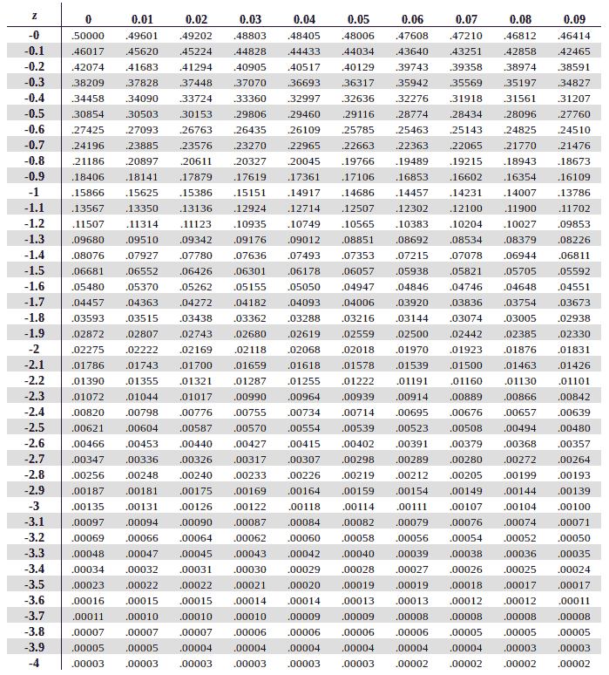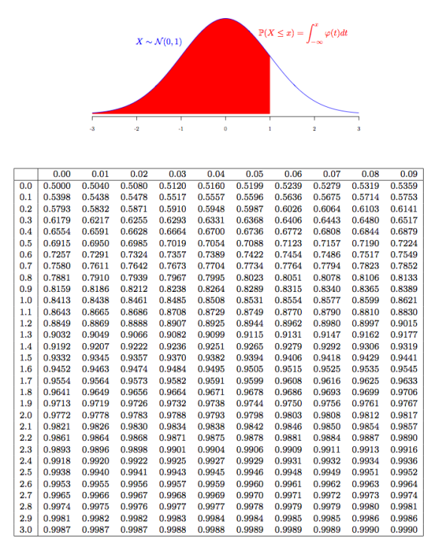
- A meteorological department is analyzing the probabilities of three independent weather alerts being issued on a given day in a region: [5 marks]
A: Flood Alert B: Landslide Alert C: Storm Alert

Based on historical data, they observe:

Each alert (A, B, or C) is equally likely to be issued: P(A)=P(B)=P(C)
The probability that any two alerts occur together (e.g., flood and landslide, landslide and storm, or storm and flood) is: P(A∩B) = P(B∩C) = P(C∩A) = $\frac{1}{8}$
The probability that all three alerts occur together is: P(A∩B∩C)= $\frac{1}{16}$
The probability of no alerts at all (completely calm weather) is: $P ( \overline{A}∩\overline{B}$ $∩\overline{C}$ ) = $\frac{1}{4}$
Now, help the department to compute:

a) The probability that a Flood Alert is issued
b) The probability that exactly two of the alerts are issued
c) The probability that at least one alert is issued
d) The probability that exactly one alert is issued

​ ************

